**Description: Bug 2.3**

Backend Error occurred whilst User presses the “buy” button without entering any value in the text box field.

Testcase 2.3: Validate "Buy" button without entering any value to given fields.

**Bug replicate:**

Go to <https://ensekautomationcandidatetest.azurewebsites.net/Energy/Buy>, press “Buy” button without entering any value for Number of Units Requires.

**Bug Image:**

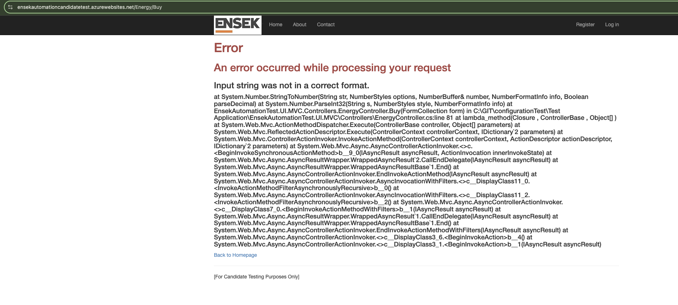

**Description: Bug 2.5**

When user enter invalid character / value in Buy text box in “Number of Units required, system gives Input error.

Testcase 2.5: Enter un-valid character or number in different format in "Number of Units Required" field to buy Gas.

**Bug replicate:**

Go to <https://ensekautomationcandidatetest.azurewebsites.net/Energy/Buy>, Enter “ABC” in Number of Units required text box and press “Buy” button.

**Bug Image:**

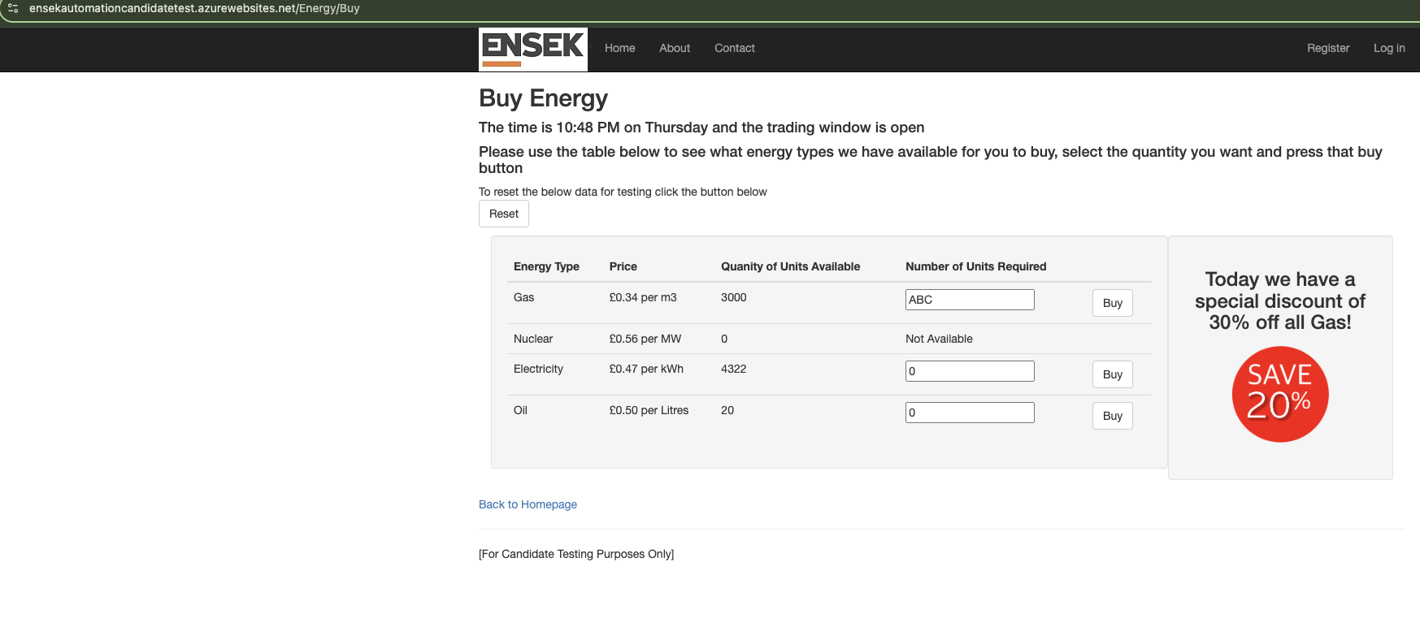

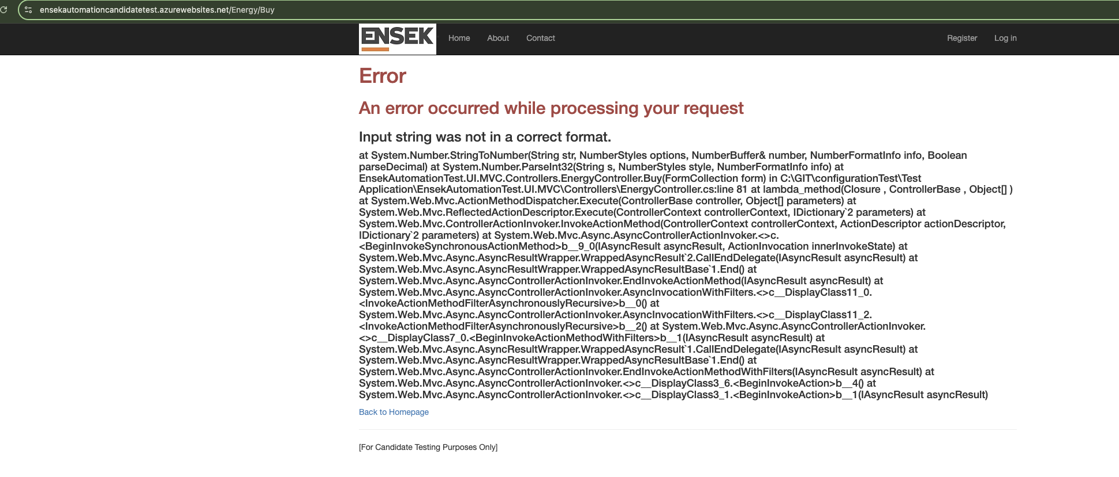

**Description: Bug 2.6**

System allows, entering a value greater or lesser than the given value in Quantity of units Available.

Testcase :2.6: Enter greater number in "Number of Units Required" field to buy Gas than the number available in "Quantity of United Available" for Gas.

**Bug replicate:**

Go the URL <https://ensekautomationcandidatetest.azurewebsites.net/Energy/Buy> and enter greater value for example 12000 in Number of Units required in text box of any of energy type.

**Bug Image:**

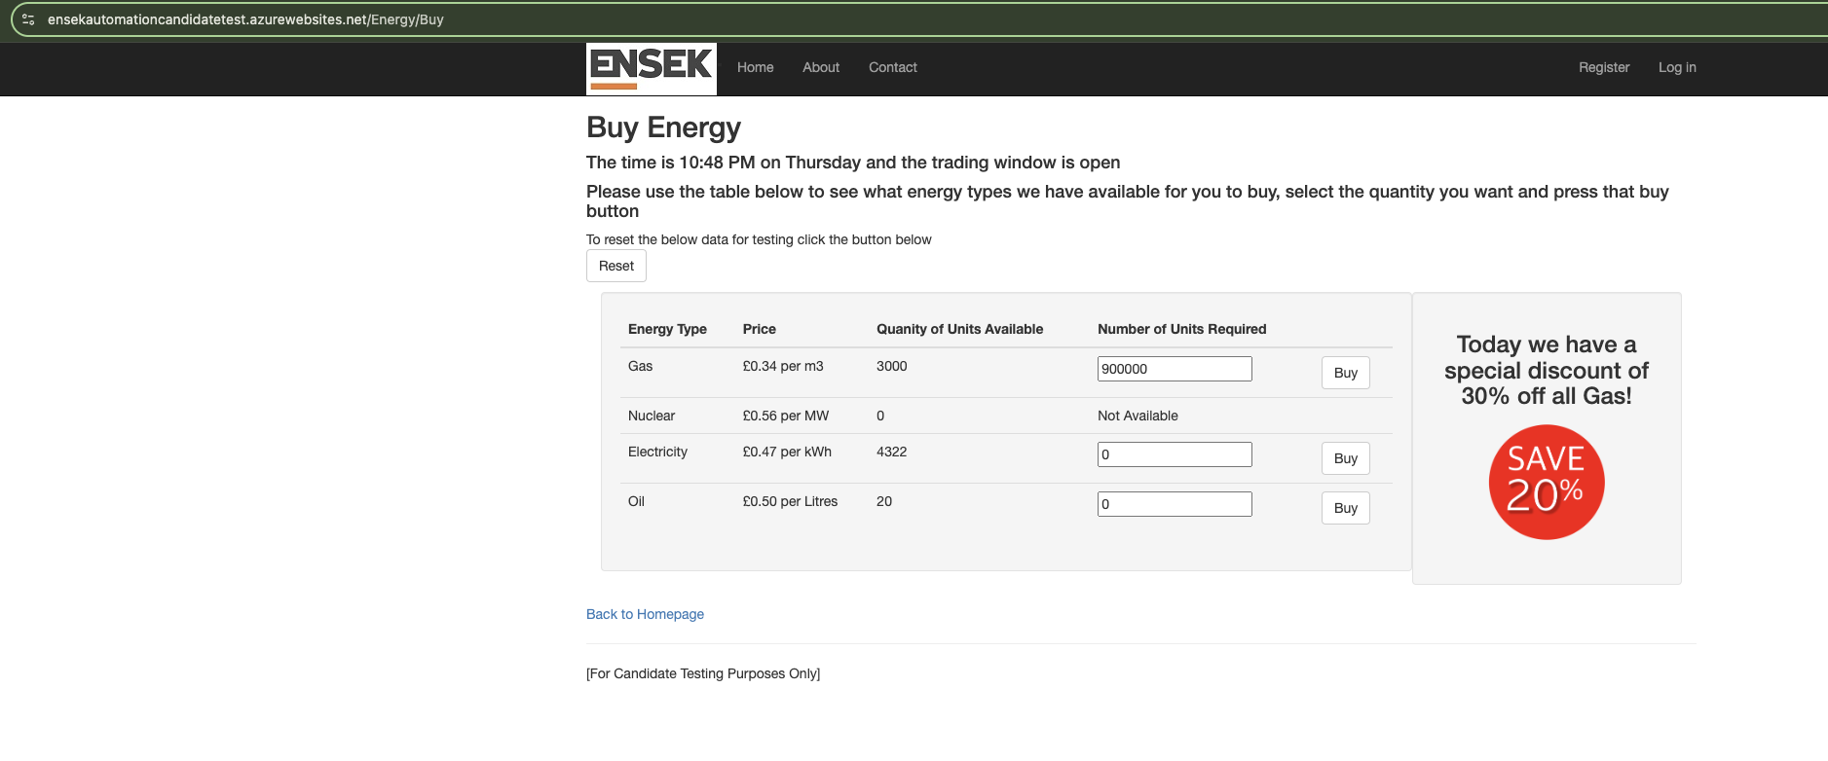

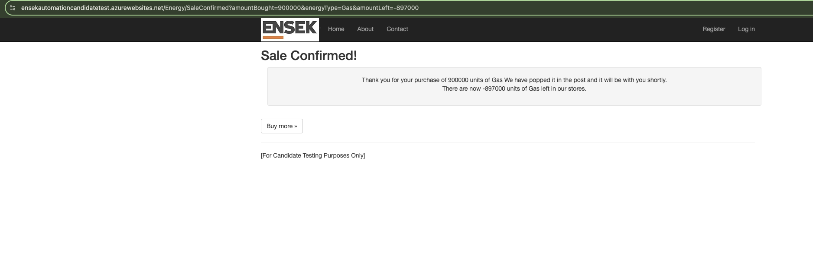

**Description: Bug 2.14**

Once the purchase of Number of units Required is confirmed, User changes the Unit value in the URL, which later reflects in the confirmation detail message.

Testcase 2.14: Verify and validate Sale Unit Confirmation of all Three Energies types. (Gas, Electricity and Gas).

**Bug Replicate:**

Place an order (<https://ensekautomationcandidatetest.azurewebsites.net/Energy/Buy> )and once the order if confirmed, change the Unit value in the URL and press enter. Notice that the updated value will appear in the detail message but won't affect the value in Energy Buy page.

**Bug Image:**

